RC tutorial 102 - Sampled formulas - Loop track  
=========================================================

Revised 2019-10-03

* This tutorial's goal is to teach you advanced use of sampled formulas.  
  While making a railway loop might not be generally useful, it will really bring you into the intended RailCOMPLETE concepts.
* Assumed skills: Basic Lua programming, alignments and the RC alignment manager.
* Assumed Railway skills: None
* Time to spend here: Expert: 30 minutes. Intermediate: 1 hour. Beginner: 2-3 hours.
* Notice to users with non-English versions of AutoCAD – see footnote[1].
* This tutorial was prepared using software release 2018.22.1302 with Norwegian DNA version “2019.1 gamma”,”NO-BN;NO-0001;2019-09-28T20:19:00+01:00;2019.1”.
* Note: If you are using AutoCAD version 2017 or older, then open the 2013-format version of the tutorial DWG file.

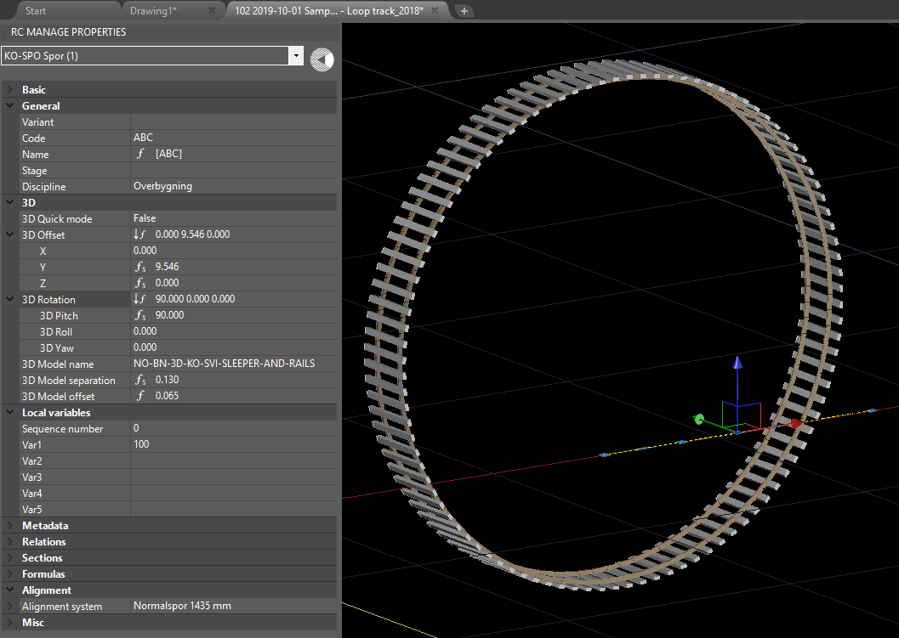

1. Start AutoCAD with RailCOMPLETE, then open the ‘General Tutorials’ folder and locate the DWG file named after this tutorial. You can either type RC-ShowGeneralTutorials or you can locate the button below the RC logo in the upper left corner of your AutoCAD window.
2. RailCOMPLETE introduced **sampled formulas** with release 2019.1. The notion of sampled formula is a formula which is evaluated (sampled) when a digital cursor slides (in steps) along an alignment’s horizontal profile (the curve it describes in the XY plane). Only alignments can have sampled formulas. The alignment properties that hold sampled formulas instead of ordinary formulas are the following:

* Offset3D.X, Offset3D.Y, Offset3D.Z
* Rotation3D.X, Rotation3D.Y, Rotation3D.Z
* Model3DName
* Model3DSeparation

1. RailCOMPLETE provides a special data structure called _position for use with sampled formulas. It has two attributes:

* _position.Pos *a real number (which we call the ‘cursor’)*
* _position.Ref *a unique identifier referencing the alignment*

1. The sampling process starts with evaluating all formulas once (sampled and ordinary)
2. _position.Pos is set to the value of Model3DOffset, as a starting value for the ‘cursor’
3. The sampled formulas are then evaluated, using the current value of _position.Pos
4. The 3D preview or export process uses the current values of all sampled and ordinary  
    formulas.
5. _position.Pos is incremented with the value along the 2D alignment which corresponds to a  
    3D displacement with the current stepsize value of ‘Model3DSeparation’ along the  
    alignment’s path in 3D space.
6. The three previous steps are repeated until _position.Pos reaches the end of the alignment’s geometry, which in this tutorial is referred to as ‘length2D’
7. length2D is accessible in Lua as *RcAlignment.HorizontalProfile.Length*  
   length3D is accessible in Lua as *RcAlignment.Length3D*
8. As an extreme example, we have provided a **loop track example**:  
     
   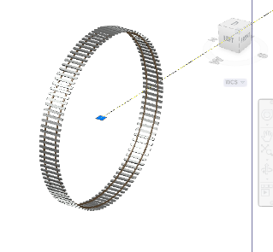
9. An alignment cannot do loops (there is just one elevation Z(s) per position ‘s’ along the geometry), but we can use the alignment as a kind of “slider” and place sleepers in 3D space as the sampled formula cursor moves along the alignment.
10. Open the Loop tutorial file.
11. Activate RC-Show3DPreview  and select the short alignment stub. The loop appears.
12. Turn on the Properties manager and inspect the 3D tab’s properties.
13. This is what the Properties manager should look like (click on the 3D and Local variables tabs to open them):  
      
    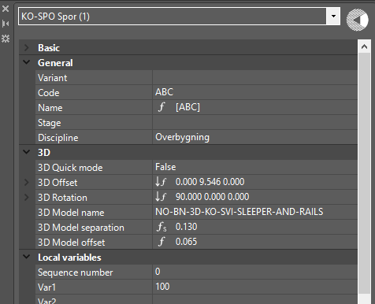
14. We have prepared a short, straight track 'ABC' for you, with 2D length 12 meters. It starts at altitude Z=5 and climbs to altitude Z=10 meters above sea level (a steep incline for a railway...). The 3D length is sqrt(12*12 + 5+5) = 13 meters. It has no cant data. It uses the 3D object model NO-BN-3D-KO-SVI-SLEEPER-AND-RAILS to express itself in 3D, a simple object model featuring two 60 cm long stubs of rail and a sleeper.
15. This is what the Alignment Manager should look like:  
      
    Horizontal alignment datagrid:  
    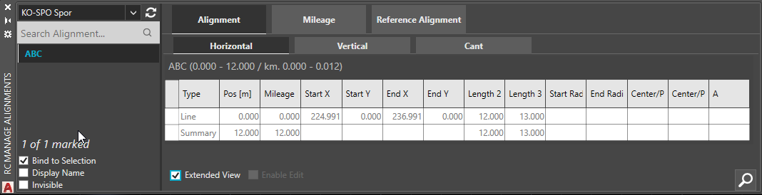  
      
    Vertical alignment datagrid:  
    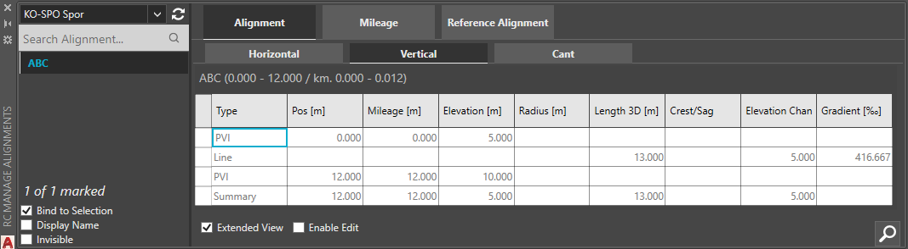  
      
    Cant datagrid (no data):  
    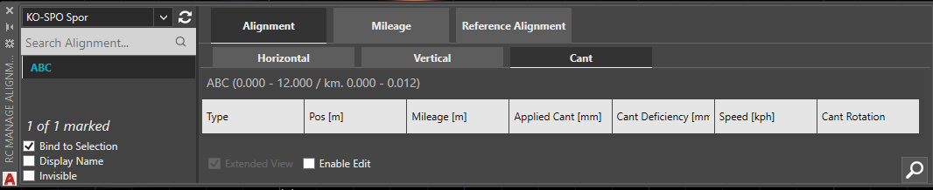
16. Change to Conceptual or Realistic mode if you want to see solids instead of wireframe objects.  
    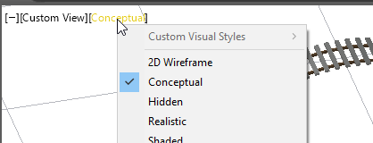
17. Open RC-ManageProperties and ensure that "3D Quick mode" in the 3D tab is set to ‘False’.
18. **Loop size.** Open the 'Local variables' tab. We have chosen to let Var1 represent the number of sleepers in the loop track, initially set to Var1 = 100.   
    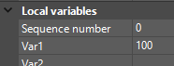
19. With some trigonometry, you will find that a polygon of N sides, each w long, has an inscribed circle with radius r = w / (2*tan(pi/N)). The loop track is inscribed in a polygon consisting of N=Var1=100 rail stubs, each w=0.6 meters long, arranged in a perfect 100-sided polygon.
20. In the '3D' tab, open the sub-tab named 'Rotation 3D'. With F3, inspect the three formulas for Pitch, Roll and Yaw. We have entered (360*s + 90) as pitch ('gradient'), where s runs from 0 to 1 as the formula is sampled along ABC. The other two formulas are void (they contain a simple value of 0). Adding 90 degrees makes the first sleeper vertical.  
     **3D Pitch (Rotation3D.X)**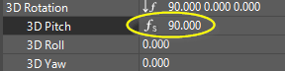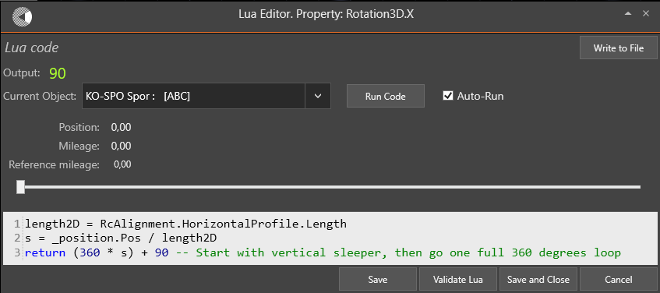
21. Open the sub-tab named '3D Offset'. You will find offset formulas for X, Y and Z.   
      
    X is sideways motion  
    Y is motion along ABC in the XY-plane  
    Z is vertical motion.  
      
    We set X(s) to zero, and we set {Y(s), Z(s)} to {r*cos(2*pi*s), r*sin(2*pi*s)}.  
      
    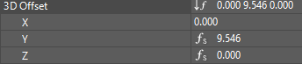  
      
    **Longitudinal motion (Offset3D.Y):   
    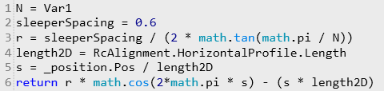  
    Vertical motion (Offset3D.Z):**  
    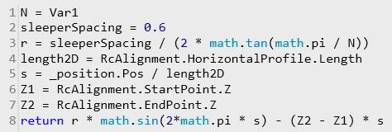
22. As you might have noticed already, there are correction terms to the above-mentioned formulas for Y and Z. Since {X,Y,Z} represents a 3D point moving along ABC's 3D curved line in space as s in our tutorial goes from 0 to 1, we will have to subtract the sleepers’ 3D insertion position at every sampled point if we shall get a loop. Therefore we subtract length2D*s from Y and (Z2-Z1)*s from Z at every sampled point along ABC. Try to remove the correction terms and see what happens.
23. You could also access the underlying Z coordinate directly: **getAlignmentInfo**(_position).Point.Z
24. Locate the 3D property ‘3D Model separation' and open it with F3. In order to obtain exactly N sleepers around the loop, we must sample ABC exactly N times. The {X,Y,Z} 3D-cursor slides along ABC's curve in 3D space as s runs from 0 to 1. The step size is therefore the 3D length of ABC divided by the number of steps we need.  
      
    **3D Model separation (Model3DSeparation)**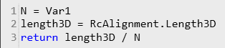
25. Add an initial Model3Doffset to s, the starting location for the sampling process, just to avoid that you get a sleeper at s=0 and one at s=1 (a total of N+1). Choosing an initial offset of Model3DSeparation/2 is always a safe bet.  
      
    **3D Model offset (Model3Doffset)**  
    
26. Try changing the number of sleepers from 100 to some other number. N=6 is shown below.   
      
    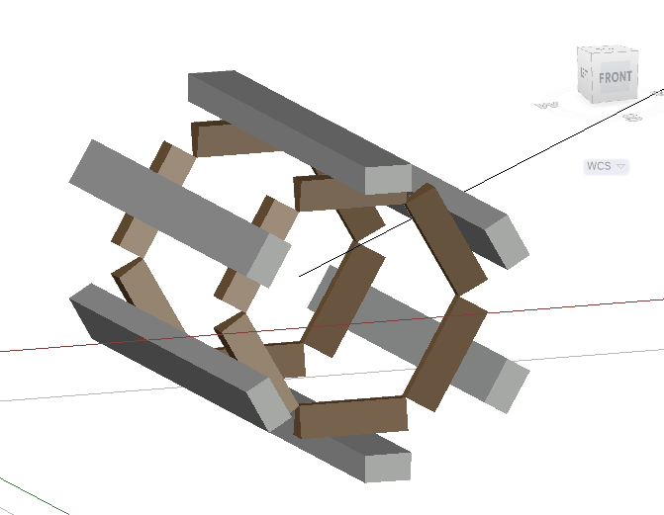
27. **Challenge**: Try adding a sideways sine curve to Offset3D.X. Try to figure out yourself how to make it wiggle sideways 3 times per loop, with a maximum sideways offset of 2 meters.  
      
    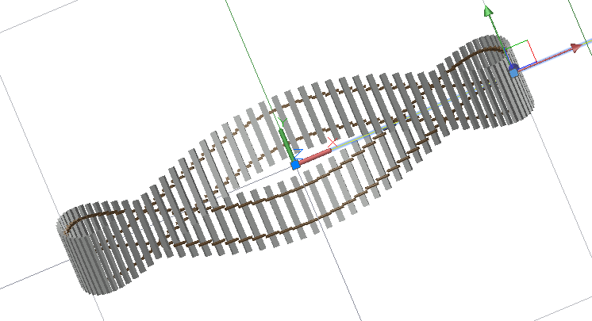

Suggestion:  
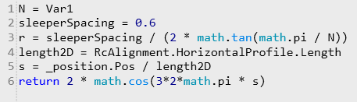

1. Instead of adding a sideways motion to Offset3D.X, you can merely adjust ABC's geometry sideways.
2. Try stretching ABC in length or modifying it any way. Try adding polyline grips to the ABC polyline in modelspace and move them sideways. Try converting line segments to arcs. To modify a grip, hover over the polyline's grip and select 'Add vertex', 'Remove vertex', 'Convert to line', 'Convert to Arc'.   
     
   NOTE: When you stretch the geometry just by moving the polyline grips in modelspace, you might extend it beyond the extents of the vertical profile data that are stored in the alignment. The results may be unexpected, depending on how well your Lua code deals with missing alignment data. Open the RC-ManageAlignments editor and check the contents of horizontal and vertical data.
3. Try using the RC-ManageAlignments editor to modify your loop. The vertical profile data must be at least as long as ABC’s geometry in order for the example formulas to work well.
4. Toggle 3D Quick mode between True and False. In 3D Quick mode, RailCOMPLETE uses standard built-in formulas for Offset3D and Rotation3D, suitable for dealing with railway tracks.  
     
   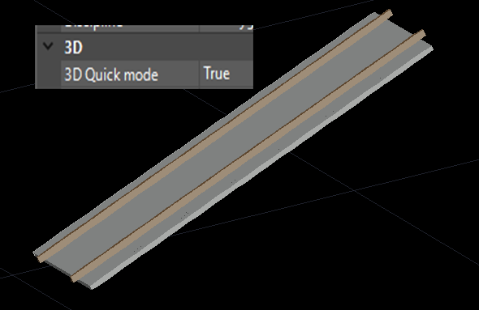
5. A more reasonable use of sampled formulas is to vary the Model3DName attribute as the cursor slides along the alignment. For instance, assume that you have a railway track with an associated 3D object model for a sleeper and two stubs of rail. You can make a formula for Model3DName that checks if the sampled function cursor is inside a switch and then suppress expressing sleepers. Or you might instead ask the switch for its construction length and add this to the Model3DSeparation stepsize to make one long jump. The switch object itself can then be expressed in its full detail as an ordinary 3D object. Also, when the sampled formula cursor moves through the switch rear part, the sleeper type can be varied from short upright 1:60 sleepers to normal length sleepers with 1:20 inclined tracks.
6. The NO-BN cable duct alignment object uses sampled formulas to insert concrete elements more often when the alignment radius is low, to account for the necessary cutting of neighbor elements to make them fit nicely:  
     
   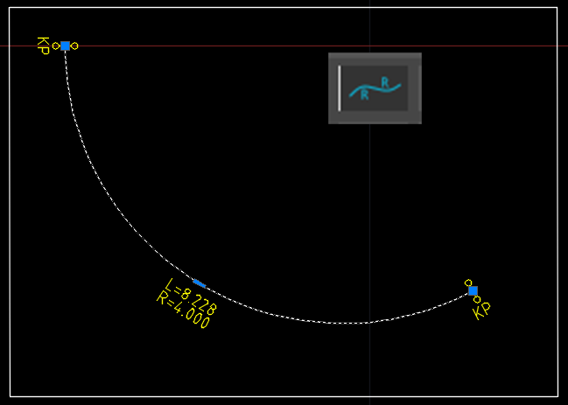 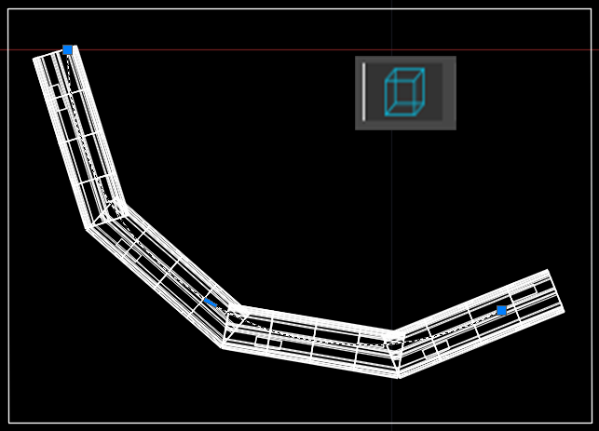
7. We really hope that you have developed a sense of understanding for the Sampled Formula concept by now, and that you are ready to apply your knowledge to your own realistic projects.
8. Have fun!

Please check our website www.railcomplete.com for updates.

Corrections and suggestions are welcome to support@railcomplete.no.

Thank you for using RC Tutorials!

1. Your AutoCAD session has probably been started from a Windows shortcut of the type:  
   “C:\Program Files\Autodesk\AutoCAD 2019\acad.exe” /product ACAD /language “fr-FR”  
   (“fr-FR” means “French language, France’s version) similar. Native AutoCAD commands may have different names in your language pack, other than the COPY, COPYBASE, FIND etc that you see in our tutorial texts. In order to instruct AutoCAD to accept the native English command name, precede the native (English) command name by an underscore character, ‘_’. For instance: ‘_FIND’ will start AutoCAD’s native ‘FIND’ command even if you are using AutoCAD with the French language pack, where the command in French is called ‘RECHERCHER’.If a command needs an argument ‘ON’, and the French menu says ‘Allumer’, then you can enter ‘_ON’ to instruct AutoCAD to use the option’s native name.